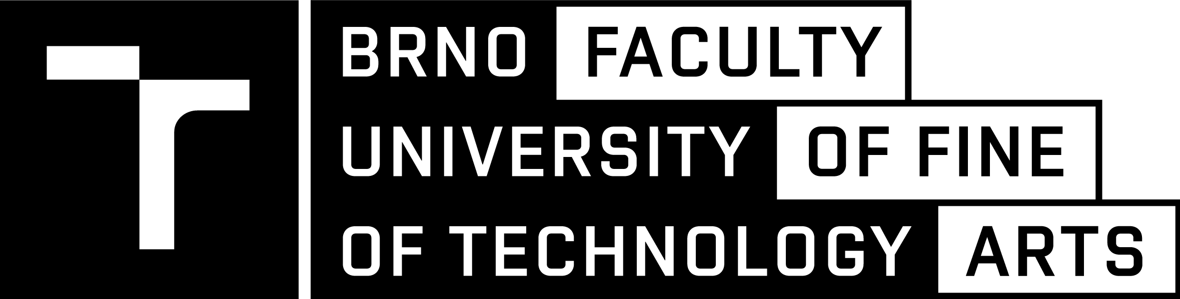

DIPLOMA PROJECT
DOCUMENTATION

BRNO UNIVERSITY OF TECHNOLOGY

FACULTY OF FINE ARTS

FINE ART AND DESIGN

DIPLOMA PROJECT TITLE

DIPLOMA PROJECT

AUTHOR | Name Surname  (including all academic titles)
SUPERVISOR | Name Surname  (including all academic titles)
BRNO 202X

ABSTRACT

150–300 words

Describe what you have done, exhibited, performed, or created for your Diploma Project. Explain why you decided to implement your project and how you managed to do so. Provide an overview of your project's key ideas: what has been explored, attempted, or challenged through your work.

CONTENTS

TEXT PART pp. XX–XX

IMAGE PART pp. XX–XX

If appropriate, the contents can be further structured into smaller sections or chapters.

text PART

500–1000 words

The text part of the Documentation of the Diploma project consists of the description of the project’s outputs and the process of their creation, including the description of the key steps of the creative process, materials, or technologies used. Authors of performative events and site-specific installations should clarify their choice of the particular place and time in which their work is set; authors of artistic research projects should justify their choice of research methods; authors of participatory projects should elaborate on selecting research collaborators and participants etc. To introduce the topic, authors may situate their position, explain their motivation to examine their topic, and analyze their inspirational sources. They should elaborate on the objectives of their work and its contribution to the field of art and design. They should justify the choice of artistic means and strategies and locate their work within the relevant contexts of contemporary fine art and design practice and/or the broader context of critical theory and visual culture.

The text part of the Diploma Project does not have to follow the format of an academic text but nevertheless requires its author to be precise and accurate, and to indicate all the sources from which they drew. Bibliographical references must adhere to the chosen citation style.

IMAGE PART

Depending on the nature of the work, the image part of the Documentation of the Diploma Project may include photographic documentation of the finished work and/or documentation of the creative process, sketches, moodboards etc. The part of the Documentation which by its nature can only be provided after the presentation and defense of the Diploma Project (e.g., photographic documentation of the performance or an installation) can be added later.

The image part of the Documentation can only contain the documentation of the diploma project.

Please make sure to provide captions for your images.

